

**SM6P07NI Digital Media Project**

**20% Report**

**2021-22 Autumn**

**Student Name: Bibek Dhungana**

**London Met ID: 20049286**

**College ID:** np01mm4s210075

**External Supervisor: Pooja Shrestha**

**Internal Supervisor : Rakshak Bajracharya**

**Assignment Due Date:**

**Assignment Submission Date: Count:**

*I confirm that I understand my coursework needs to be submitted online via Google Classroom under the relevant module page before the deadline in order for my assignment to be accepted and marked. I am fully aware that late submissions will be treated as non-submission and a marks of zero will be awarded.*

**Abstract**

*-* The following documentation gives a brief overview of the research and development part of the project idea for the Final Year Project. The content of this documentation provides a thorough introduction to the topic of the Final Year Project i.e., Game Environment/ Asset Creation. It further elaborates on the topic of history of big game industries and indie game developers, impact of game easily accessible game engines and finally the unreal marketplace and its advantages.

In early years of game development, only big companies were able to make industry standard games as it required a huge number of artists working together but with the introduction of game development software like Unreal Engine and Unity, this number has been decreased to as small as a single person. Today, artist/developer have the tools required to make AAA game on their own. (Beattie, 2021). Some developers tend to create all their assets by themselves as they have control over everything but most of the developers look for the required assets on the internet and marketplaces to meet the deadline or avoid unnecessary tedious work. Being a field that is always developing and changing, the game development community has gained lots of new tools and techniques that has made the process of creating 3D environments and game levels in no time. Artists love to bring their 3D environment concepts to life as fast as possible. With the help of online asset marketplaces like unreal engine marketplace, artist can choose from thousands of pre-made assets that fits their style. With this workflow, artist can spend their time on other areas like lighting, post-processing, composition and just in general world building from block out without having to spend a lot of time on creating assets.

The following documentation covers the research part of what it takes to create a personalized game environment. The reason this project can be called “personalized” is because the art style and aesthetical influence for this project comes from traditional and cultural sites in Nepal.

Contents

1 Introduction 1

1.1 Topic 2

1.2 Area of Research 3

2 Aims of Project 4

3 Target Audience 5

3.1 Primary Target audience: Game Developers/ Environment Artists 5

3.2 Secondary Audience: Players/Gamers 5

4 Product Research 6

4.1 Stylized Fantasy Provencal 6

4.2 Stylized Forest 7

4.3 Stylized Japanese Temple 8

5 Technologies Employed 9

6 Project Plan 11

6.1 Production Flowchart 11

6.2 Previous Timeline 11

7 Production Phases 13

7.1 Introduction to GDLC approach 13

❖ Pre-Production 14

7.2 Story/Idea 14

7.3 Phase 2: Conceptual Analysis 14

7.4 Phase 3: Game Planning 15

7.5 Phase 4: Prototype and Blockout 15

7.6 Phase 5: Concept Design 16

❖ Production 17

7.7 Phase 6: Development 17

7.7.1 Modelling/ Asset Creation 17

7.7.2 Texture Creation 35

7.7.3 Texturing 54

7.7.4 Unreal Engine 4.27 72

❖ Post-Production 108

7.7.5 Blueprints 108

7.7.6 Audio Setup 111

8 Resources 112

8.1 Hardware and Devices: 112

8.2 Software 112

9 User Testing & Findings 113

9.1.1 Test 01 114

9.1.2 Test 02 115

9.1.3 Test 03 116

9.1.4 Test 04 117

9.1.5 Testing Results 118

10 Conclusion 119

11 References 120

12 Bibliography 121

*13* Appendix 122

Table of Figures

Figure 1 Patan Final Map ................................................................................................ 2

Figure 2 Collection of Software workflow ........................................................................ 3

Figure 3 Product Review 01 ............................................................................................ 6

Figure 4 Product Review 02 ............................................................................................ 7

Figure 5 Product Review 03 ............................................................................................ 8

Figure 6 Software Logos ................................................................................................. 9

Figure 7 Project Plan Flowchart .................................................................................... 11

Figure 8 Old Timeline .................................................................................................... 11

Figure 9 New Timeline .................................................................................................. 12

Figure 10 GDLC Cycle .................................................................................................. 13

Figure 11 Story References .......................................................................................... 14

Figure 12 Asset list planning ......................................................................................... 14

Figure 13 Workflow Planning ........................................................................................ 15

Figure 14 First Block Out environment .......................................................................... 15

Figure 15 Prototype and Blockout ................................................................................. 16

Figure 16 References Gathering ................................................................................... 16

Figure 17 Final Layout Concept Art ............................................................................... 16

Figure 18 Props Concept Arts ....................................................................................... 17

Figure 19 Modelling vs Real Life Comparision .............................................................. 17

Figure 20 Tree Modelling 01 ......................................................................................... 18

Figure 21 Tree Modelling 02 ........................................................................................ 18

Figure 22 Tree Modelling 03 ......................................................................................... 19

Figure 23 Tree Modelling 04 ......................................................................................... 19

Figure 24 Tree Modelling 05 ......................................................................................... 20

Figure 25 Tree Modelling 06 ......................................................................................... 20

Figure 26 Tree Modelling 07 ........................................................................................ 21

Figure 27 Tree Modelling 08 ......................................................................................... 21

Figure 28 Tree Modelling 09 ......................................................................................... 22

Figure 29 Foliage Modelling 01 ..................................................................................... 22

Figure 30 Foliage Modelling 02 ..................................................................................... 23

Figure 31 Foliage Modelling 03 ..................................................................................... 23

Figure 32 Foliage Modelling 04 ..................................................................................... 24

Figure 33 Foliage Modelling 05 ..................................................................................... 24

Figure 34 Props Modelling 01 ...................................................................................... 25

Figure 35 Props Modelling 02 ....................................................................................... 25

Figure 36 Props Modelling 03 ...................................................................................... 26

Figure 37 Props Modelling 04 ....................................................................................... 26

Figure 38 Props Modelling 05 ....................................................................................... 27

Figure 39 Props Modelling 06 ....................................................................................... 27

Figure 40 Props Modelling 07 ...................................................................................... 28

Figure 41 Props Modelling 07 ....................................................................................... 28

Figure 42 Props Modelling 08 ....................................................................................... 29 Figure 43 Props Modelling 09 .......................................................................................29

Figure 44 Props Modelling 10 .......................................................................................30

Figure 45 Modular House Building 01 ...........................................................................30

Figure 46 Modular House Building 02 ...........................................................................31

Figure 47 Stumps Modelling 01 .....................................................................................31

Figure 48 Stumps Modelling 02 .....................................................................................32

Figure 49 Stumps Modelling 03 .....................................................................................32

Figure 50 Stumps Modelling 04 ..................................................................................... 33

Figure 51 Stumps Modelling 05 ..................................................................................... 33

Figure 52 Stumps Modelling 06 ..................................................................................... 34

Figure 53 Barl Textire Final ........................................................................................... 35

Figure 54 Bark Texture Creation 01 .............................................................................. 35

Figure 55 Bark Texture Creation .2 ............................................................................... 36

Figure 56 Bark Texture Creation 03 .............................................................................. 36

Figure 57 Final Grass Textures ..................................................................................... 37

Figure 58 Grass Texture Creation 01 ............................................................................ 38

Figure 59 Grass Texture Creation 02 ............................................................................ 38

Figure 60 Grass Texture Creation 03 ............................................................................ 38

Figure 61 Final Grass Texture ....................................................................................... 39

Figure 62 Final Rocky Grass Textures .......................................................................... 39

Figure 63 Final Tiled Grass Textures ............................................................................ 39

Figure 64 Final Dirt Texture ........................................................................................... 40

Figure 65 Dirt Texture Creation 01 ................................................................................ 40

Figure 66 Dirt Texture Creation 02 ................................................................................ 41

Figure 67 Dirt Texture Creation 03 ................................................................................ 41

Figure 68 Normal Dirt Texture Final Output .................................................................. 42

Figure 69 Rocky Dirt Texture Final Output .................................................................... 42

Figure 70 Tiled Dirt Texture Final Output ...................................................................... 42

Figure 71 Moss Texture Showcase ............................................................................... 43

Figure 72 Moss texture creation 01 .............................................................................. 43

Figure 73 Moss texture creation 02 .............................................................................. 44

Figure 74 Moss Texture Final Output ............................................................................ 44

Figure 75 Foliage Texture Creation 01 .......................................................................... 45

Figure 76 Foliage Texture Creation 02 .......................................................................... 45

Figure 77 Foliage Texture Creation 03 .......................................................................... 46

Figure 78 Foliage Texture Creation 04 .......................................................................... 46

Figure 79 Foliage Texture Creation 04 ..........................................................................47

Figure 80 Foliage Texture Creation 05 ..........................................................................47

Figure 81 Foliage Texture Creation 06 ..........................................................................48

Figure 82 Foliage Texture Creation 07 ..........................................................................48

Figure 83 Wind Variation Texture Creation 04 ..............................................................49

Figure 84 Wind Variation Texture Creation 05 ..............................................................49

Figure 85 Wind Variation Texture Creation 06 ..............................................................49 Figure 86 Wind Variation Texture Creation 07 ..............................................................50

Figure 87 Wind Variation Texture Creation 08 ..............................................................50

Figure 88 Wind Variation Texture Creation 09 ..............................................................50

Figure 89 Wind Variation Texture Creation 10 ..............................................................51

Figure 90 Wind Variation Texture Creation 11 ..............................................................51

Figure 91 Final Foliage Textures ...................................................................................52

Figure 92 Final Leaves Texture .....................................................................................53

Figure 93 Final Caustics Textures ................................................................................. 53

Figure 94 Final Grass Variation Texture ........................................................................ 53

Figure 95 Boat Texturing 01 .......................................................................................... 54

Figure 96 Boat Texturing 02 .......................................................................................... 54

Figure 97 Boat Texturing 03 .......................................................................................... 55

Figure 98 Boat Texturing 04 ......................................................................................... 55

Figure 99 Boat Texturing 05 .......................................................................................... 56

Figure 100 Boat Texturing 06 ........................................................................................ 56

Figure 101 Fence Texturing 01 ..................................................................................... 57

Figure 102 Fence Texturing 02 ..................................................................................... 57

Figure 103 Fence Texturing 03 ..................................................................................... 58

Figure 104 Fence Texturing 04 ..................................................................................... 58

Figure 105 Fence Texturing 05 ..................................................................................... 59

Figure 106 Fence Texturing 06 ..................................................................................... 59

Figure 107 Fence Texturing 07 ..................................................................................... 59

Figure 108 Modular Piece Texturing 01 ........................................................................ 60

Figure 109 Modular Piece Texturing 02 ........................................................................ 60

Figure 110 Modular Piece Texturing 03 ........................................................................ 61

Figure 111 Modular Piece Texturing 04 ........................................................................ 61

Figure 112 Modular Piece Texturing 05 ........................................................................ 62

Figure 113 Modular Piece Texturing 06 ........................................................................ 62

Figure 114 Modular Piece Texturing 07 ........................................................................ 63

Figure 115 Modular Piece Texturing 08 ........................................................................ 63

Figure 116 Modular Piece Texturing 09 ........................................................................ 64

Figure 117 Modular Piece Texturing 10 ........................................................................ 64

Figure 118 Modular Piece Texturing 11 ........................................................................ 65

Figure 119 Modular Piece Texturing 12 ........................................................................ 65

Figure 120 Modular Piece Texturing 13 ........................................................................ 66

Figure 121 Modular Piece Texturing 14 ........................................................................ 66

Figure 122 Fence Texturing 01 .....................................................................................67

Figure 123 Fence Texturing 02 .....................................................................................67

Figure 124 Fence Texturing 03 .....................................................................................68

Figure 125 Fence Texturing 04 .....................................................................................68

Figure 126 Stump Texturing 01 .....................................................................................69

Figure 127 Stump Texturing 02 .....................................................................................69

Figure 128 Stump Texturing 04 .....................................................................................70 Figure 129 Stump Texturing 03 .....................................................................................70

Figure 130 Stump Texturing 05 .....................................................................................70

Figure 131 Stump Texturing 06 ....................................................................................71

Figure 132 Final Output Unreal Engine .........................................................................72

Figure 133 First Prototype Level ...................................................................................72

Figure 134 Blockout level ..............................................................................................73

Figure 135 Final Version of the blockout level ...............................................................73

Figure 136 Shader Collection ........................................................................................ 74

Figure 137 Stylized Water creation 01 .......................................................................... 74

Figure 138 Stylized Water creation 02 .......................................................................... 74

Figure 139 Stylized Water creation 03 .......................................................................... 75

Figure 140 Stylized Water creation 04 .......................................................................... 75

Figure 141 Stylized Water creation 05 .......................................................................... 76

Figure 142 Stylized Water creation 06 .......................................................................... 76

Figure 143 Stylized Water creation 07 .......................................................................... 77

Figure 144 Stylized Water creation 08 .......................................................................... 77

Figure 145 Stylized Water creation 10 .......................................................................... 78

Figure 146 Stylized Water creation 09 .......................................................................... 78

Figure 147 Grass RVT creation 01 ................................................................................ 79

Figure 148 Grass RVT creation 02 ................................................................................ 79

Figure 149 Grass RVT creation 03 ................................................................................ 80

Figure 150 Grass RVT creation 04 ................................................................................ 80

Figure 151 Grass RVT creation 06 ................................................................................ 81

Figure 152 Grass RVT creation 05 ................................................................................ 81

Figure 153 M_Log creation 01 ...................................................................................... 82

Figure 154 M_Log creation 02 ...................................................................................... 82

Figure 155 M_Log creation 03 ...................................................................................... 83

Figure 156 M_Log creation 04 ...................................................................................... 83

Figure 157 M_Log creation 05 ...................................................................................... 84

Figure 158 M_Log creation 06 ...................................................................................... 84

Figure 159 M_Flower 01 ............................................................................................... 85

Figure 160 M_Flower 02 ............................................................................................... 85

Figure 161 M_Props Creation01 ................................................................................... 86

Figure 162 M_Props Creation 02 .................................................................................. 86

Figure 163 Landscape Material Creation 01 ................................................................. 87

Figure 164Landscape Material Creation 02 .................................................................. 87

Figure 165Landscape Material Creation 03 ..................................................................88

Figure 166Landscape Material Creation 04 ..................................................................88

Figure 167Landscape Material Creation 05 ..................................................................89

Figure 168Landscape Material Creation 06 ..................................................................89

Figure 169Landscape Material Creation 07 ..................................................................90

Figure 170Landscape Material Creation 08 ..................................................................90

Figure 171Landscape Material Creation 09 ..................................................................91 Figure 172Landscape Material Creation 10 ..................................................................91

Figure 173 Asset Setup 01 ............................................................................................92

Figure 174 Asset Setup 02 ............................................................................................92

Figure 175 Asset Setup 03 ............................................................................................92

Figure 176 Asset Setup 04 ............................................................................................93

Figure 177 Asset Setup 05 ............................................................................................93

Figure 178 Procedural Foliage Scattering Setup 01 ......................................................94

Figure 179 Procedural Foliage Scattering Setup 02 ...................................................... 94

Figure 180 Fx Creation 01 ............................................................................................. 95

Figure 181 Fx Creation 02 ............................................................................................. 95

Figure 182 Fx Creation 03 ............................................................................................. 96

Figure 183 Fx Creation 04 ............................................................................................. 96

Figure 184 Fx Creation 04 ............................................................................................. 97

Figure 185 Fx Creation 05 ............................................................................................. 97

Figure 186 Fx Creation 06 ............................................................................................. 98

Figure 187 Fx Creation 07 ............................................................................................. 98

Figure 188 Fx Creation 08 ............................................................................................. 99

Figure 189 Final Level Creation 01 ............................................................................... 99

Figure 190 Final Level Creation 01 ............................................................................. 100

Figure 191 Final Level Creation 02 ............................................................................. 100

Figure 192 Final Level Creation 03 ............................................................................. 101

Figure 193 Final Level Creation 04 ............................................................................. 101

Figure 194 Final Level Creation 05 ............................................................................. 102

Figure 195 Final Level Creation 04 ............................................................................. 102

Figure 196 Final Level Creation 05 ............................................................................. 103

Figure 197 Final Level Creation 06 ............................................................................. 103

Figure 198 Final Level Creation 07 ............................................................................. 104

Figure 199 Final Level Creation 08 ............................................................................. 104

Figure 200 Final Level Creation 09 ............................................................................. 105

Figure 201 Final Level Creation 10 ............................................................................. 105

Figure 202 Final Level Creation 11 ............................................................................. 106

Figure 203 Final Level Creation 12 ............................................................................. 106

Figure 204 Final Level Creation 13 ............................................................................. 107

Figure 205 Final Level Creation 14 ............................................................................. 107

Figure 206 Final Level Creation 15 ............................................................................. 108

Figure 207 Blueprint Creation 01 ................................................................................ 108

Figure 208 Blueprint Creation 02 ................................................................................ 109

Figure 209 Blueprint Creation 02 ................................................................................ 109

Figure 210 Blueprint Creation 03 ................................................................................ 110

Figure 211 Blueprint Creation 04 ................................................................................ 110

Figure 212 Audio Setup 01 .......................................................................................... 111

Figure 213 Audio Setup 02 .......................................................................................... 111

Figure 214 Software List Logo .................................................................................... 112 Figure 215 Respondent 01 .......................................................................................... 114

Figure 216 Respondent 01 Testing ............................................................................. 114

Figure 217 Respondent 02 .......................................................................................... 115

Figure 218 Respondent 02 Testing ............................................................................. 115

Figure 219 Respondent 03 .......................................................................................... 116

Figure 220 Respondent 03 Testing ............................................................................. 116

Figure 221 Respondent 04 .......................................................................................... 117

Figure 222 Respondent 04 Testing ............................................................................. 117

Figure 223 Evaluation Testing Results ........................................................................ 118

# 1 Introduction

This documentation provides a brief overview for the second coursework for the module “Digital Media Project (SM6P07NI)”. The coursework covers 20% of the total assessment weight. In previous documentation for the module, the students had to provide research and development for their individual projects. Thus, for this semester the students must complete their individual projects and provide the supervisors with proper documentations comprising of overall production process, evidence, problem solving, and overall testing of the finished product.

This document briefly covers the efforts of an individual to create a game environment from scratch. It further covers the aims of the project, its target audience, technologies employed, and the resources and techniques used to deliver the final product.

## 1.1 Topic

**“PATAN – A Nepalese Environment Stylized Asset Pack”**

The topic for the project was inspired by various environment artists who were putting up different asset packs related to their country and tradition on the unreal marketplace. The whole idea for this project is to provide an asset pack and overview of the pack that contains different assets to create a game environment inspired by the traditions and colours of **Nepalese culture and tradition**.

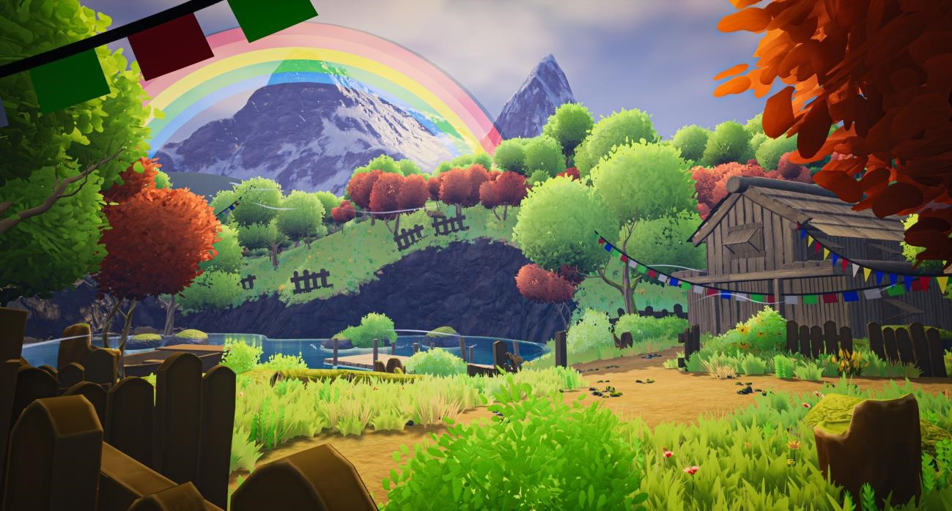

*Figure 1 Patan Final Map*

## 1.2 Area of Research

As mentioned earlier, the game development topic is a vast one. Thus, the amount and area of research is very large as well. From texturing, modelling, texture creation, shader setup, effects, to game environment building, all these topics had to be properly researched before starting the production process.

First was the research for texture creation. Texture creation and texturing process is completely different. In texture creation, the texture is created using different noises where else in texturing the assets are textured using various presets provided by the software. After the texture creation, the assets had to be modelled. Thus, the research for modelling included the creation of foliage meshes such as flowers, trees, and other plants. In addition, the modelling process of modular building meshes were researched. This was done to create maximum variation by using least amount of meshes.

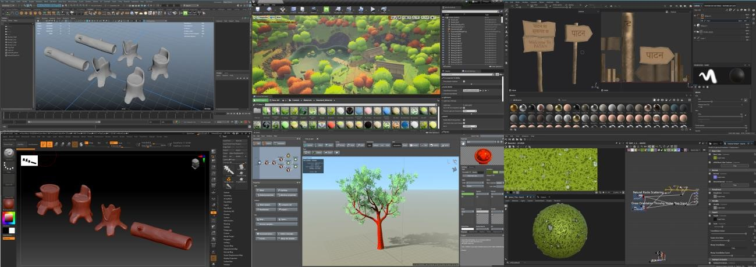

*Figure 2 Collection of Software workflow*

# 2 Aims of Project

If any artist has to create their own assets, the production time would add to their overall project time which would then lead them spending unnecessary time in creating something that is already available on the marketplace. The overall process of asset creation alone is very time consuming and technique heavy. The process of asset creation involves of small staps like concept art, high poly modelling, low poly modelling, baking and UV, texture mapping, rigging, animating and many more. The project management skill alone would not be enough to finish this process in time. Further the whole process of asset creation needs research and skills on variety of different software. An artist alone would have to spend years to master the skills to make industry standard game assets. Thus, the trend of game developers using the marketplace assets is growing regularly. This is simply because these asset packs reduce the overall effort and time consumption of the production.

Patan contains various modular meshes, pieces from small architectural pieces to large buildings. Together with high quality rocks, foliage and traditional rural Nepalese modular pieces, this asset pack allows game developers and environment artists to create a map with traditional Nepalese influenced assets. Using this asset pack, the environment creation and detailing process is made faster. As mentioned above, the production process is all about testing the functionality of the game and making the game look more pretty. Thus, this asset pack contains perfect optimized assets to make any game level look pretty. Since the pack is stylized, the asset is minimalistic and simple. All the details in the asset comes from either the normal map or the shader setups. In addition to the assets, this pack also comes with personalized shader setups for FX and one particle system. The personalized shader uses different tools and techniques inside unreal like Runtime Virtual Texture and Custom Stylized Fog system to make the game look more stylized.

In conclusion, the main aim of this asset pack is to help game developers in creating optimized stylized environments easily with premade personalized assets. In addition, this project also has an objective of introducing and inspiring game developers to creating traditionally influenced **Nepalese art style** game environments which would then be a step forward in games creation that would be relatable to Nepalese gaming audiences as well as game developers.

# 3 Target Audience

## 3.1 Primary Target audience: Game Developers/ Environment Artists

**Age:** 12-50 years old

**Gender:** All genders

**Genre Specification:** Stylized Game Environment/Level Artists

**Nationality:** All Nationality

The overall process of asset creation is very time consuming and would add unnecessary production time to the process of game creation. The process of asset creation involves of small staps like concept art, high poly modelling, low poly modelling, baking and UV, texture mapping, rigging, animating and many more.

## 3.2 Secondary Audience: Players/Gamers

**Age:** 12-50 years old

**Gender:** All genders

**Genre Specification:** Stylized Games

**Nationality:** All Nationality

# 4 Product Research

## 4.1 Stylized Fantasy Provencal

The first product that was researched was the Stylized Fantasy Provencal. The first thing that was noticed for the research was the stylization of the assets

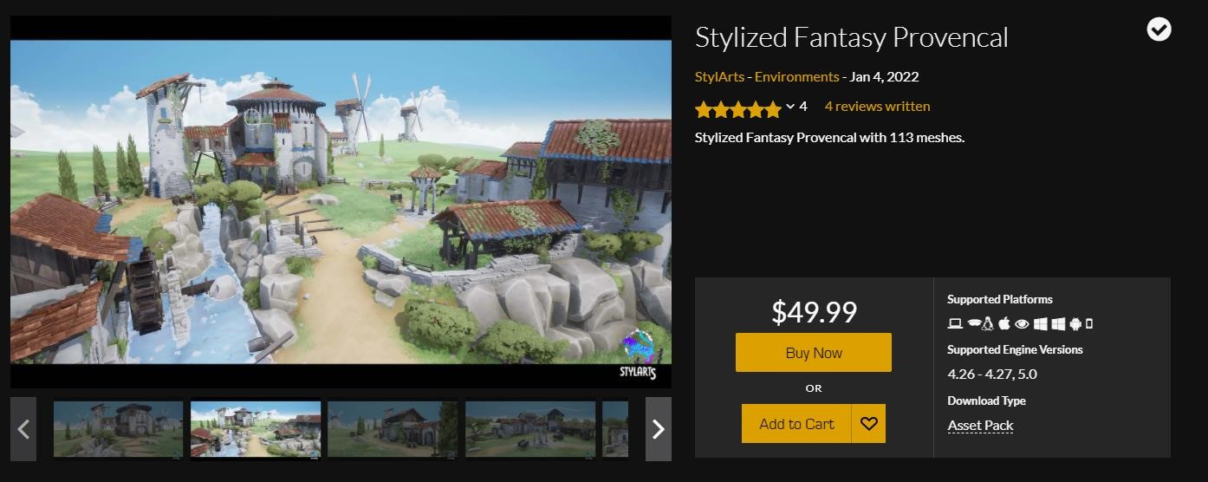

*Figure 3 Product Review 01*

* **Supported Platforms**: HoloLens 2, Linux, MacOs, Oculus, Windows, Android and IOS
* **Supported Unreal Versions:** 4.26 – 4.27, 5.0
* **Download Type:** Asset Pack

**Review:**

The attention to detail is very high/ The asset pack has a unique style that is reflected in the overview map. The style can be noticed in the concept and design of the props as wellThe pack also includes a landscape material that can be painted on the get the desired foliage scattering effect as well as to make different pathways between a green grass layer. The collisions are automatically generated, and the assets have LODs. The pack also provides three different texture sizes which can help in optimizing the asset or the whole level on the basic of what machine the game is going to run on.

## 4.2 Stylized Forest

Another product that was quite similar to the layout and concept of this asset pack was the stylized forest pack.

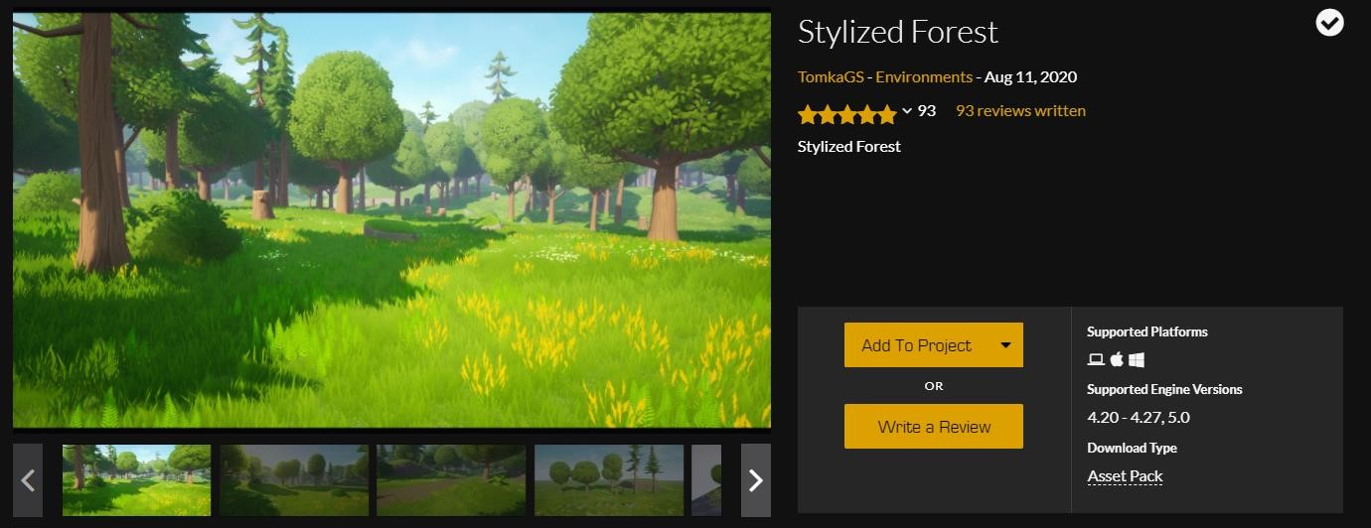

*Figure 4 Product Review 02*

* **Supported Platforms**: Windows and MacOS
* **Supported Unreal Versions:** 4.20 – 4.27, 5.0
* **Download Type:** Asset Pack

❖ **Review:**

Right from the first glance the foliage looks well optimized. Different variety of same foliage type can be seen in the overview map that helps break up the. Same thing was done in this product as well. The foliage meshes are all different but textured using the same texture. This way the texture required count becomes low and the scene becomes more optimized. Further this pack also contains an auto landscape material. Which means the developers don’t have to go and paint every bit of landscape that they want to feature in their work. The wind is added to all kinds of foliage in the asset pack. Most of the material can be instanced which provides the user with different finer controls over the material. The overview map is small but showcases the assets in the asset pack very well.

## 4.3 Stylized Japanese Temple

The third and final map chosen for the product review was the stylized Japanese Temple map.

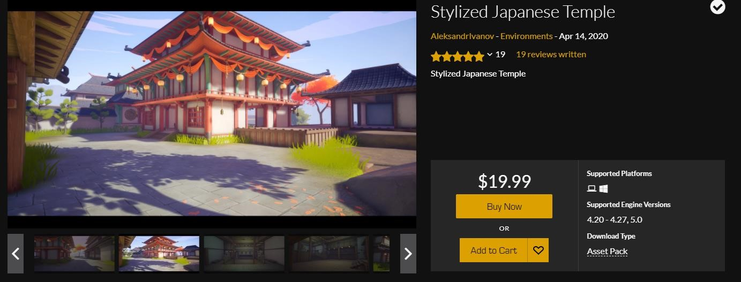

*Figure 5 Product Review 03*

* **Supported Platforms**: Windows
* **Supported Unreal Versions:** 4.20 – 4.27, 5.0
* **Download Type:** Asset Pack

❖ **Review:**

The showcase video provides a total overview of the asset pack. It shows the overall showcase map created to display all the assets together. This way a buyer can evaluate the map and decided to buy the pack or not. The players can walk around the environment exploring the area of the map. Further the players can also enter the buildings. The building and the temples look very optimized and well-made as the players can enter through them. The foliage looks stylized and blends right in with the rest of the environment. The trees are given a bright red orange colour. The map even contains a flag rope that extends from building to building. This is very similar to what was planned for this project asset pack as well.

# 5 Technologies Employed

*Figure 6 Software Logos*

* **Adobe Illustrator 2020**

Adobe Illustrator was used to create foliage alpha and textures.

* **Blender 3.0**

Blender was used to create the leaf meshes for the tress and make custom alphas for the tree leaf meshes.

* **Gaea**

Gaea is a specialized software which creates terrains and landscapes. For this project Gaea was used to create the distant hero mountain.

* **Autodesk Maya**

Autodesk Maya was used to model and texture different assets for the project.

* **Substance Designer**

Substance Designer was used to create textures by combining noises together.

* **Substance Painter**

The majority of sculpted assets were textured in substance painter and then exported to Unreal Engine.

* **Speedtree**

Speedtree was used in this project to create personalized stylized looking trees which were a huge part of this project.

* **zBrush**

zBrush is used in this project for sculpting different assets and adding high level of details.

* **Unreal Engine**

The majority of the production work was done inside Unreal Engine. It was used for blockout levels, prototyping, shader setup, mesh setup, asset texturing, lookdev, fx creation, blueprints and finally setting up the audio for the final product.

# 6 Project Plan

## 6.1 Production Flowchart

# 7 Production Phases

## 7.1 Introduction to GDLC approach

## ❖ Pre-Production

## 7.2 Story/Idea

## 7.3 Phase 2: Conceptual Analysis

**7.7.1.1 Trees Modelling**

* **Normal Grass Texture Output:**
* **Rocky Grass Texture Output:**
* **Tiled Grass Texture Output:**

**7.7.2.3 Ground Dirt Texture and its Variations**

* **Normal Dirt Texture Output:**
* **Rocky Dirt Texture Output:**

* **Tiled Dirt Texture Output:**

**7.7.2.4 Moss Texture**

* **Final Moss Texture Output:**

**7.7.2.5 Foliage Texture Creation**

**7.7.2.6 Final Foliage Textures**

### 

### 7.7.3 Texturing

**7.7.3.1 Boat Texturing**

### 7.7.4 Unreal Engine 4.27

**7.7.4.1 Shader Setup**

* **M_Grass_RVT**

* **M_Log**

* **M_Flower**

* **M_Props**

**7.7.4.2 Landscape Material Setup**

**7.7.4.3 Assets and Props Setup**

**7.7.4.4 Procedural Foliage Scattering**

**7.7.4.5 FX Creation**

**7.7.4.6 Final Levels Creation**

### 

### 7.7.5 Blueprints

### 7.7.6 Audio Setup

# 8 Resources

## 8.1 Hardware and Devices:

* MSI Desktop Monitors
* LEGION 5 with NVIDIA GTX 1650ti

## 8.2 Software

A total of 3 software was used in the production of this product.



*Figure 214 Software List Logo*

* **Adobe Photoshop 2020.**
* **Blender.**
* **Autodesk Maya.**
* **Substance Painter.**

# 9 User Testing & Findings

Testing is said to be the most important phase of the GDLC model process. Testing and game design have the same weight in the game/concept development architecture. This is performed when a game development is accomplished for one cycle. So, the testing was carried out on four respondents ranging with 3D industry experience of 4 to 5 years. The criterial and elements of the testing process is mentioned in the table below.

|  |  |  |  |
| --- | --- | --- | --- |
| **Element** | **Criteria** | **Marking (out of 50)** | **Experiences** |
| Gameplay | The game can  quickly attract the attention the players. | 10 | Excellent  Pleasant Poor |
| Traditionally Relatable | The visual of the map is relatable to the artists. | 10 | Excellent  Pleasant Poor |
| Assets Look and Feel | Game feels optimized and ran smoothly. | 10 | Excellent  Pleasant Poor |
| UI and Audio | The UI feels easy and are easily guided by it. | 10 | Excellent  Pleasant Poor |
| Immersion | Players immerge in the game and  feel less aware of the surrounding environment. | 10 | Excellent  Pleasant Poor |

### 9.1.1 Test 01

### 9.1.2 Test 02

### 9.1.3 Test 03

### 9.1.4 Test 04

### 9.1.5 Testing Results

# 10 Conclusion

The 20% documentation for the Digital Media Project is now complete. The history of gaming and game creation, how it developed, and the breadth of game production in the modern world were initially covered because this coursework was all about creating game environments.

Due to its scale and prospects, this project has made a positive impact on the 3D sector. The tools developed for this project facilitate the building of gaming environments. Focus and perseverance were needed for this project at every stage of creation. Eventually, this project has produced an incredible degree of productivity thanks to each stage being carried out precisely and thoroughly.

# 11 References

# 12 Bibliography

# *13* Appendix

